**eLM Academic Consultants**

**Software Development Project with ASU**

**eLM Academic Consultants Quality Review Database Visuals**

There would be two main sections in the database:

1. View for Inputting Reviews
2. Client View to View Reviews

Below is a listing of capabilities that would be great for the database:

* Ability to change the master template so that standards can be adjusted
* Ability to copy an existing review so that when a re-review is completed, the affected standards can be updated
* Ability for the client to save a copy of the review as a PDF (I didn’t mention this on our last call.)

**Visuals for Inputting Reviews Section**

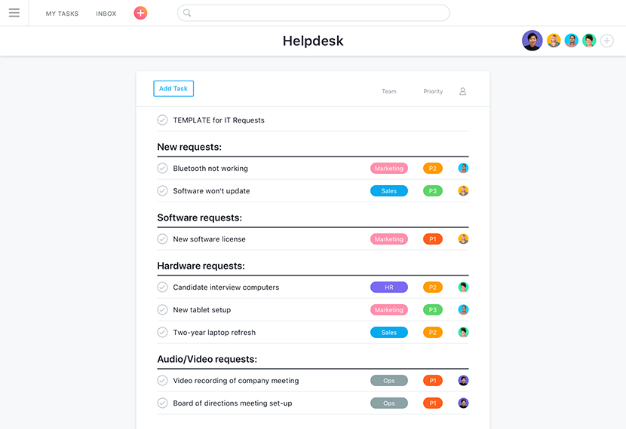

* If when we are in the middle of completing a review, if possible, for each standard to show an overview of the completion. Either ‘completed’ or ‘in progress’

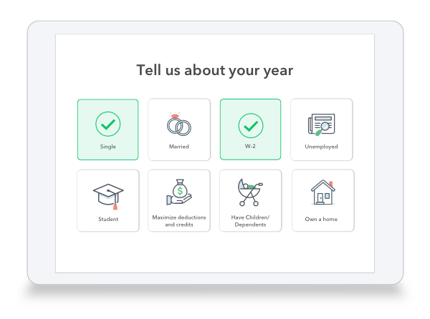

* Something like this for each of the 8 standards would allow the reviewers and clients to easily skip to that standard.

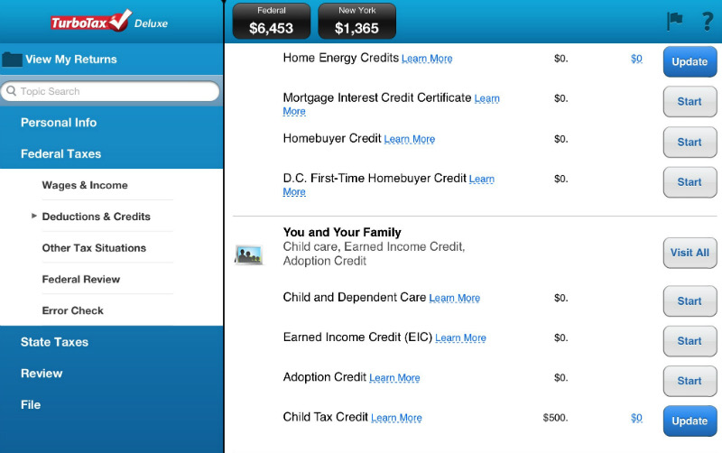

* I like the menu on the left hand side that would show each of the 8 standards, broken down by sub standards (for both reviewer view and client view.)

**Visuals for Client View Section**

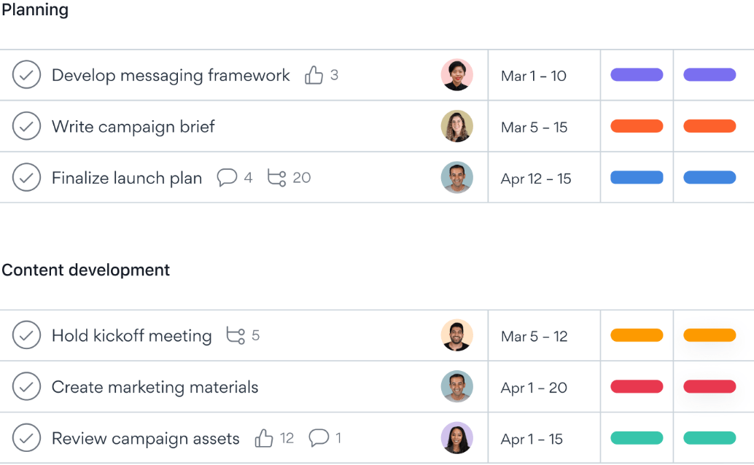

* If when a client goes to view the completed review, if they could see the Standards broken down like this with the ability to see the points and colour (red for not met, green for met for each standard)

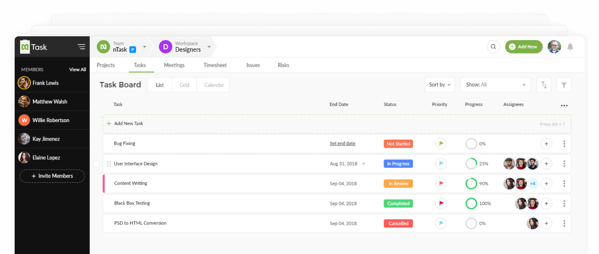

* If when a client logs in, they could see their reviews presented something like this. With the colour coding met or not met, along with the scores.